How to Register/Log in
- Open your Internet Browser (Internet Explorer, Firefox, etc). Click on the following link, or copy and paste it into the web browser:
https://login.myschoolbuilding.com/msb?acctNum= insert account number&productID=IND
- If you are a returning user, enter your Email Address and Password. Click Sign In.
- If you have forgotten your password, click the Forgot Password? Link and enter your email address. We’ll send you instructions for resetting your password.
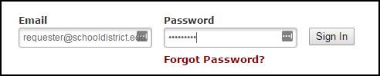
- If you are submitting your first request, you must enter registration information first. Click on the down arrow () next to Never Submitted a Request? Register Here! to expand the registration form. *Note: Your registration will be complete after you submit your first work request.
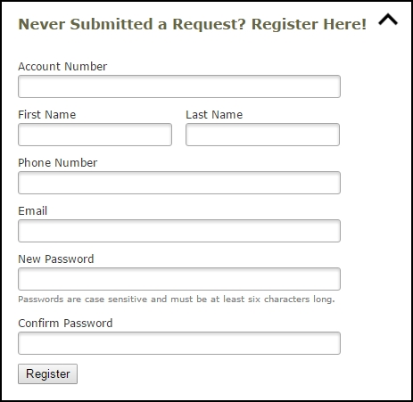
  - Enter the Account Number provided by your Administrator.
  - Enter your First and Last Name, as well as your Phone Number and Email Address.
  - Type the Password you would like to use to log into your SchoolDude account and confirm it. The password you choose must be 6 characters long.
  - Click Register to go to the work order request form.

The Dude Says:
To create a shortcut to your desktop, find a blank area on this screen and right click on your mouse. You will have the option to create a shortcut or add to your favorites. Creating a shortcut will add an icon to your desktop. You can double click it the next time you want to sign in.

How to Submit a Request
- Make sure you are on the Inventory Request tab at the top of the screen.
*Note: Any field marked with a red checkmark is a required field.
- Step 1: Enter the Submittal Password of type password here and click Submit to begin.
- Step 2: You will see a listing of available inventory items. If you wish to filter or search for a specific item, you have a few options:
  - Filter using the Catalog or Commodity drop down menus.
  - Enter a word identifying the item into the box next to Item Description, then click Go.
  - Select the letter that the inventory item begins with using the numbers/letters next to Current sort Item Description.
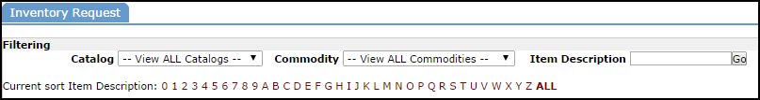
- Step 3: Enter the quantity of the item(s) that you are requesting and update your cart by clicking on the Add to Cart button.
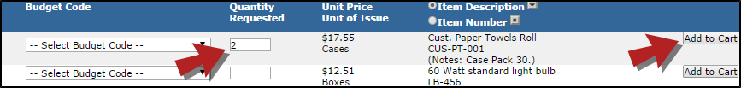
*Note: The Add to Cart button to the right of the item will only add that one item to your cart. If you select multiple items on your screen and would like to add them to you cart all at one time, click on the Add/Update Cart button at the bottom of the screen.

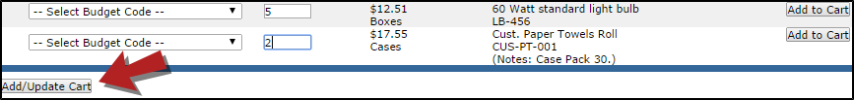

- Step 4: Once all inventory items have been added to the cart, it is time to submit your request. Click the View Cart link located in the upper right hand corner of your screen.
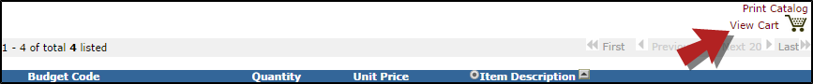
- Step 5: Double check and finalize your order.
  - Your Contact Information will already be filled in for you.
  - Select your Location (required field).
  - Select Area and Area Number, if applicable.
  - Confirm that your item(s) and quantity are correct.
  - Your password will already be filled in, but in case it was deleted it is password.
  - Click the Submit as Request button.
Note: If you selected an inventory item in error and you would like to make a change prior to submitting the request, click on the red X to the right of the item. Click on the Back to Inventory Request List if you would like to select another item.

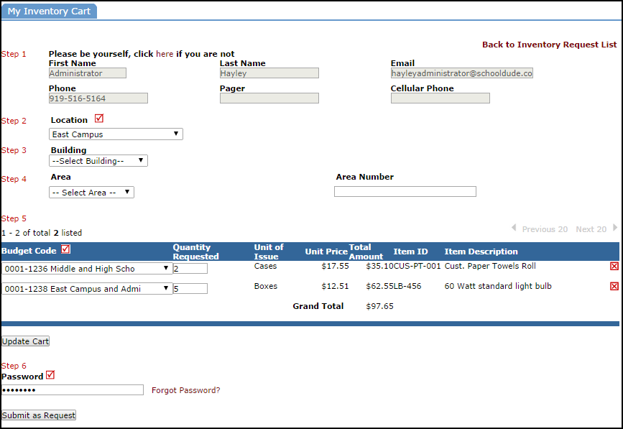

My Request Tab
You can view any requests that you have entered into the system by clicking on the My Requests tab. Hover your mouse over the Shortcuts link and click on My Inventory Requests. You will see a listing of any requests that you have entered into the system. You are also able to print out a listing of your requests by clicking on the printer icon.
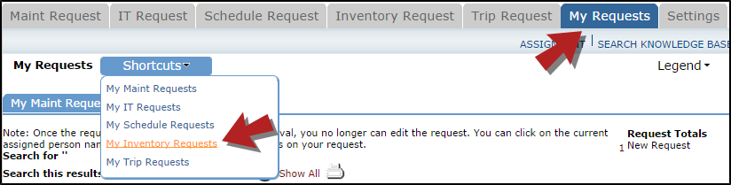
On the My Requests page you will see up-to-date information on your requests including the current status, item number and description, the date you requested the inventory, and the date approved. You can search for any inventory request by typing in a keyword in the box next to Search this results for then click on GO. This will pull any of your requests according to the keyword that you searched for.

